**What is AWS CloudHSM?**

AWS Cloud HSM provides hardware security modules in the AWS Cloud. A hardware security module (HSM) is a computing device that processes cryptographic operations and provides secure storage for cryptographic keys.

When you use an HSM from AWS Cloud, you can perform a variety of cryptographic tasks:

• Generate, store, import, export, and manage cryptographic keys, including symmetric keys and asymmetric key pairs.

• Use symmetric and asymmetric algorithms to encrypt and decrypt data.

• Use cryptographic hash functions to compute message digests and hash-based message

authentication codes (HMACs).

• Cryptographically sign data (including code signing) and verify signatures.

• Generate cryptographically secure random data.

If you want a managed service for creating and controlling your encryption keys, but you don't want or need to operate your own HSM, consider using AWS Key Management Service.

**How does CloudHSM work?**

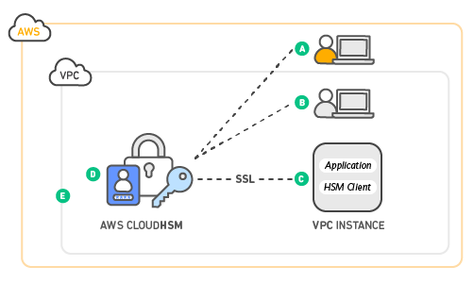

**Contents:**

• AWS CloudHSM use cases

• AWS CloudHSM clusters

• AWS CloudHSM cluster backups

• AWS CloudHSM Client SDK

• HSM users

• Pricing

• Regions

• AWS CloudHSM quotas

**AWS CloudHSM use cases:**

A hardware security module (HSM) in AWS CloudHSM can help you accomplish a variety of goals.

**Topics:**

• Offload the SSL/TLS processing for web servers

• Protect the private keys for an issuing certificate authority (CA)

• Enable transparent data encryption (TDE) for Oracle databases

**AWS CloudHSM clusters:**

AWS CloudHSM provides hardware security modules (HSMs) in a cluster. A cluster is a collection of individual HSMs that AWS CloudHSM keeps in sync. You can think of a cluster as one logical HSM. When you perform a task or operation on one HSM in a cluster, the other HSMs in that cluster are automatically kept up to date.

You can create a cluster that has from 1 to 28 HSMs is 6 HSMs per AWS account per AWS Region). You can place the HSMs in different Availability Zones in an AWS Region.Adding more HSMs to a cluster provides higher performance. Spreading clusters across Availability Zones provides redundancy and high availability.

Making individual HSMs work together in a synchronized, redundant, highly available cluster can be difficult, but AWS CloudHSM does some of the undifferentiated heavy lifting for you. You can add and remove HSMs in a cluster and let AWS CloudHSM keep the HSMs connected and in sync for you.

**Cluster Architecture:**

